**RandomPageRedirect Feature Documentation**

The RandonPageRedirect feature allows a user in the wiki to select the random tab in the top of the html and be redirected to a “random” page that exists on the index page.

The following files are added:

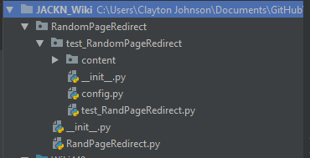

The following files are modified:

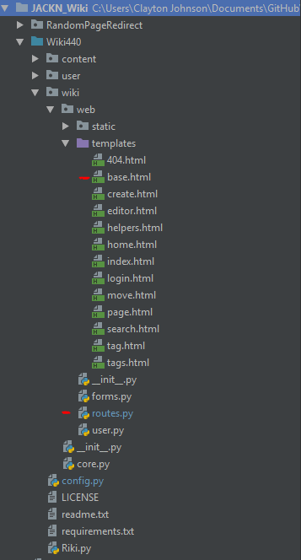

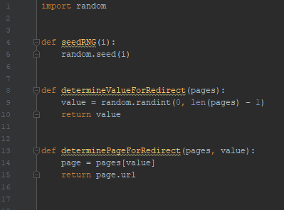

RandPageRedirect.py

3 methods exist within RandPageRedirect.

seedRNG takes an integer and seeds the random number generator.

determineValueForRedirect(pages) takes a list of pages as its parameter. It determines an integer value between 0 and the number of pages – 1. This allows for selection of a page from the full list. The integer value is returned.

determinePageForRedirect(pages, values) takes in a list of pages and an integer value as its parameters. The page selected is the one at the index for the random value generated in the previous method. The url of the page is returned.

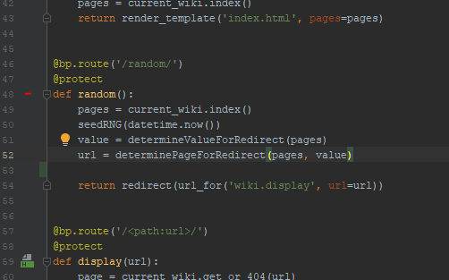

Routes.py

Function random is added. Its route is /random/ which is a decorator for the url. The current pages are loaded from the wiki’s index. Next, RandPageRedirect.py’s seedRNG method is called to seed the rng with the current datetime and simulate randomness. Then, the value of the list index to be selected is decided and finally the url is determined from the page. Then a redirect is called using wiki.display as a template.

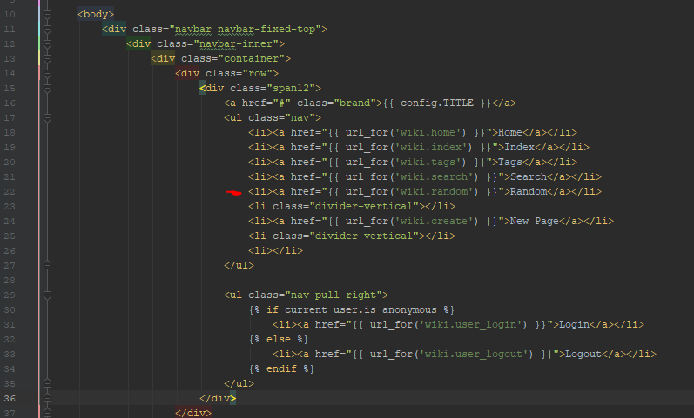

Base.html

A navbar element is added that uses the wiki.random function